**Guide for Annie:** T

This is the scientist’s legend. I think it’d be good to outline the Blackest and whitest census tracts as an entire chunk where possible. Outlining each little census tract would probably look too busy. If the Blackest census tracts can be outlined in one color and the whitest census tracts can be outlined in another that we specify on a legend that would be great! If you can remove the transect somehow, that would also be good since that was for something the scientist studied in her PhD that is not relevant to the article.

I’d also convert the scientist’s legend to Fahrenheit.

I left the census tract outlines in the right place for you, but it’s two separate pictures. In the article, I’ll be putting it side by side with a different map that I made showing census demographics, to demonstrate that the Blacker the neighborhood, the more severe the effects of climate change.

The Blackest census tracts are yellow. The whitest census tracts are purple.

33 Celsius = 91.4 Fahrenheit

12.8 Celsius = 55.04 Fahrenheit

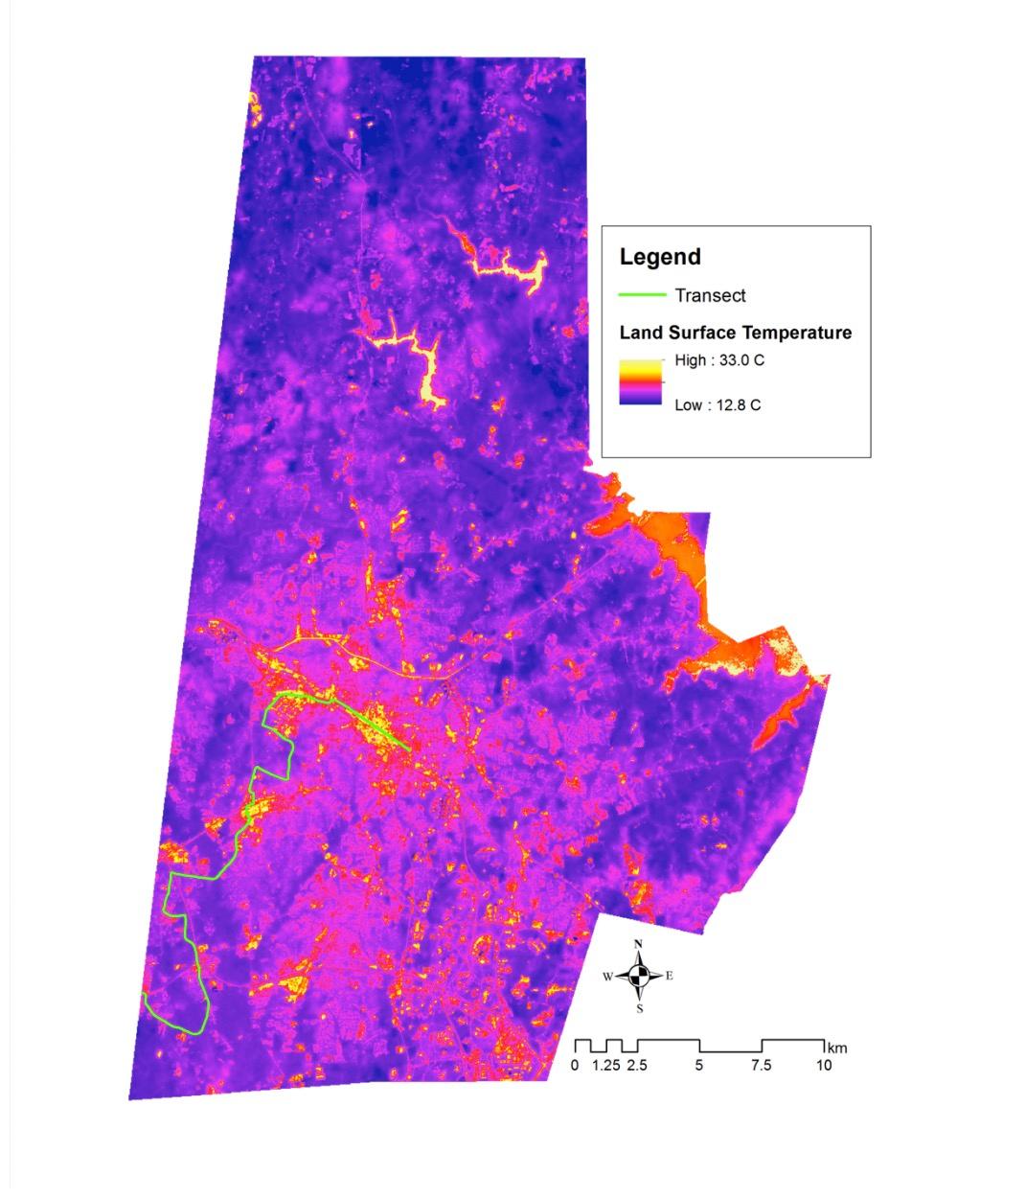

22.9 – halfway = red

Orange = 27.95

17.85 = puirple

